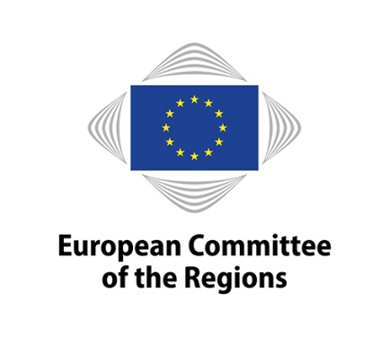 | Press Release
CoR/21/48.en
Brussels, 17 March 2021

Stronger regional dimension for the European Education Area

The Covid-19 crisis has underlined the importance of resilient education systems that pave the way towards a green economy based on knowledge and the digital transformation. The European Committee of the Regions (CoR) supports the European Commission's efforts to achieve the European Education Area by 2025 but calls to take better into account regional needs and to address regional disparities in the field of education. The CoR opinion was presented at the plenary session on Wednesday by rapporteur Emil Boc (RO/EPP), Mayor of Cluj-Napoca.

The CoR considers that attaining the Sustainable Development Goals and pursuing environmental sustainability should be key goals of the European Education Area. The dual environmental and digital transition should be mainstreamed into all educational processes and cross-cutting objectives for education and training. Member States' progress should be assessed through a roadmap, annual indicators and benchmarks.

"While local and regional authorities' remits in the field of education vary widely from one Member State to another, they have direct and comprehensive ties to the communities where education policies shaped at European level are implemented and where those policies have a direct impact. Therefore, the strategic objectives of the European Education Area need to be matched with clear, identifiable financial resources available to local and regional authorities", said rapporteur Emil Boc, who served as Prime Minister of Romania between 2008 and 2012.

MEP Michaela Šojdrová (CZ/EPP), European Parliament's rapporteur on the European Education Area, said: "I believe we all share the idea that high quality education is an answer to the current and future challenges, including digital and green transitions. But it was hit the hardest by the COVID-19 pandemic. I intend to put forward a European Parliament report that will be realistic and will aim at common strategy towards the European Education Area, shared and implemented by all institutions and actors at European, national and local level."

Mr Boc's opinion points out that regions and cities can help to identify regional education needs and promote specific policies which take account of local circumstances. Particular focus should be on reducing current education disparities between rural and urban areas, stages in the education system and educational establishments. Poor education is generally linked to poverty and inadequate individual resources and is a key factor behind brain drain.

The opinion also highlights the importance of building strategic partnerships between local and regional authorities and their universities, as well as other formal and non-formal education and training establishments. This would help provide much-needed lifelong learning programmes for upskilling and reskilling to enable people to stay or enter a fast changing labour market in the green and digital transitions.

More information
The Joint Action Plan signed in November 2020 between the CoR's SEDEC Commission and Commissioner Mariya Gabriel's services (Directorate-General for Education, Youth, Sport and Culture, Directorate-General for Research and Innovation and the Joint Research Centre) foresees that the CoR will be involved in consultations related to the implementation of the European Education Area and to the Education for Climate Coalition.

The CoR published this week a new study on the active contribution of the subnational level to the achievement of a European Education Area. By identifying and analysing educational and training initiatives implemented by local and regional authorities across the EU, it concludes that progress across the EU has been mixed and there are important disparities sometimes even across regions within the same country. It also provides evidence of the type of reactions and supporting measures that were deployed in early 2020 as a consequence of the Covid-19 pandemic.

Contact:
Lauri Ouvinen
Tel. +32 473536887
lauri.ouvinen@cor.europa.eu

The European Committee of the Regions

The European Committee of the Regions is the EU's assembly of regional and local representatives from all 27 Member States. Created in 1994 following the signing of the Maastricht Treaty, its mission is to involve regional and local authorities in the EU's decision-making process and to inform them about EU policies. The European Parliament, the Council and the European Commission consult the Committee in policy areas affecting regions and cities. To sit on the European Committee of the Regions, all of its 329 members and 329 alternates must either hold an electoral mandate or be politically accountable to an elected assembly in their home regions and cities. Click here for more details on your national delegation.
Your personal data are processed in accordance with the requirements of Regulation (EU) 2018/1725 of the European Parliament and of the Council of 23 October 2018 on the protection of natural persons with regard to the processing of personal data by the Union institutions, bodies, offices and agencies and on the free movement of such data and repealing Regulation (EC) No 45/2001 and Decision No 1247/2002/EC. You may, upon request, obtain the details of your personal data, rectify any inaccurate or incomplete personal data, or ask for your data to be removed from our mailing list.

Should you have any queries concerning the processing of your personal data, please address them to PresseCdr@cor.europa.eu. You can also send an email to the CoR data protection officer data.protection@cor.europa.eu. As regards the processing of your personal data, you have a right to recourse at any time to the European Data Protection Supervisor https://edps.europa.eu/about-edps/contact_en.
For further information about our privacy policy, please visit the page: https://cor.europa.eu/en/Pages/legal-notice.aspx.

